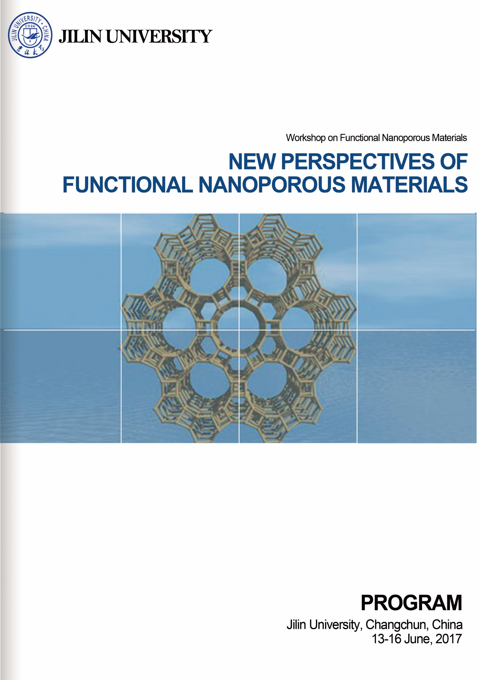
WORKSHOP PROGRAM
Wednesday, 14 June, 2017, Lecture Hall (II), Auditorium
Time | Speaker | Title | Chairperson
08:30 - 08:40 | Opening Ceremony Jihong Yu
08:40 - 09:15 | Stefan Kaskel | New Metal-Organic Frameworks with Ultrahigh Porosity, Switchability and Functionality | Guangshe Li
09:15 - 09:50 | Fabrizio Cavani | Mixed Metal Oxides for Gas-phase Reactions: Bio-alcohols and Polyols Transformation to Added Value Chemicals | Guangshe Li
09:50 - 10:20 | Coffee Break
10:20 - 10:55 | Gopinathan Sankar | On the Formation of Zeolites through in situ and ex situ X-ray Techniques | Jean-Pierre Gilson
10:55 - 11:30 | Peng Zhang | X-ray Spectroscopy of Some Metal Nanostructures | Jean-Pierre Gilson
11:30 - 11:50 | Group Photo
12:00 | Lunch
13:30 - 14:05 | Fei Wei | Hierarchical Zeolite Structures and Their Application on Methanol to Propylene and Aromatics | Sheng Dai
14:05 - 14:40 | Jean-Pierre Gilson | Designer Zeolites: Better, Smaller, More Accessible and… Cheap | Sheng Dai
14:40 - 15:10 | Coffee Break
15:10 - 15:45 | Bao-Lian Su | Natural Law of Hierarchizing Holds Key to Enhancing Photocatalysis, Amplifying Gas Sensing and Extending Battery Life | Gopinathan Sankar
15:45 – 16:20 | Jihong Yu | Zeolitic Materials: Prediction, Synthesis and Application | Gopinathan Sankar
16:20 | Laboratory and Campus Tour
18:00 | Dinner

Thursday, 15 June, 2017, Lecture Hall (II), Auditorium
Time | Speaker | Topic | Chairperson
08:50 - 09:25 | Sheng Dai | Porous Ionic Liquids: Challenges and Opportunities | Justin D. Holmes
09:25 – 10:00 | Guangshan Zhu | Targeted Synthesis of Porous Aromatic Frameworks: From Structure Design to Advanced Application | Justin D. Holmes
10:00 - 10:30 | Coffee Break
10:30 - 11:05 | Lixin Wu | Supramolecular Self-Assembly of Inorganic Clusters for Soft Frameworks | Bao-Lian Su
11:05 - 11:40 | Justin D. Holmes | Nanoparticle Promoters in Organic and Inorganic Reactions | Bao-Lian Su
12:00 | Lunch
13:30 - 14:05 | Xiulian Pan | Porous Materials and Selectivity Control in Syngas Conversion | Guangshan Zhu
14:05 - 14:40 | Ben Slater | Computational Modelling Signposts New Directions in Porous Materials | Guangshan Zhu
14:40 - 15:15 | Sanliang Ling | Computational Studies of Metal-Organic Frameworks: Defects, Electronic Properties and Gas Adsorptions | Guangshan Zhu
15:15 - 15:25 | Closing Remarks Jihong Yu
15:25 | Coffee and Free Discussion with Faculties and Students
18:00 | Dinner

